

INVITATION TO TENDER

CRS Sudan, under the TAADOD, funded by DFID, invites competent and qualified companies to submit their bids for the following.

|  |  |  |
| --- | --- | --- |
| **S/no** | **Category Reference** | **Ref: No. CRS-Sudan-BU-RFGS-28576** |
| 1 | **Supply and design Gabion Boxes with below specifications** |  |

**Specifications for goods/Services required**

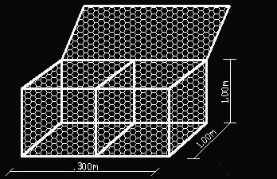

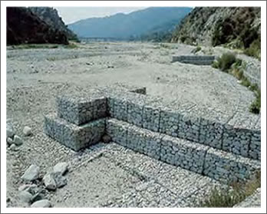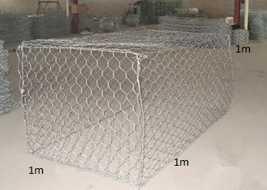

|  |  |
| --- | --- |
| **General** | The size and type of wire mesh, diaphragms binding wires, and selvedge wire are specified in the following paragraphs. The fabric of the gabions shall be triple twisted hexagonal woven steel wire mesh. The wire shall be galvanized before weaving. All wire used in the manufacture and tying of gabion shall comply with the BS.1052: 1980 "Mild steel wire for general engineering purposes" and shall be galvanized in accordance with BS 443: 1982 "Specifications for testing zinc coatings on steel wire and for quality requirements." |
| **Mesh** | The gabion boxes shall have hexagonal woven mesh with a maximum size of 10 cm x 12 cm, with the joints fonned by twisting each pair of wires through three half turns. Wire used for the fonnation of the mesh panel will have a diameter of 3.0mm. |
| **Wire** | The diameter of the wire used in the fabrication of the mesh shall be 3.0 mm. Sufficient binding and tie wires, horizontal and vertical bracers, and other accessories needed for the assembly and erection of the gabion works shall be supplied, at no additional cost, by the Contractor. The quantity of such wire shall be not less than 10% by weight of the [gabions](https://www.gaviones.org/gabions/index.html) supplied under this Contract. The diameter of the binding and connection wires shall be 2.4 mm. |
| Galvanizing | All wire used in the manufacture of gabion boxes and in the wiring operations during construction shall be heavily coated with zinc. The minimum weight of zinc coating shall be as follows:    The adhesion of the zinc coating to the wire shall be strong enough of an **extent that when the wire is wrapped six turns around a mandrel of four times** the diameter of the wire, it does not flake or crack to such an extent that any zinc can be easily removed by rubbing with the bare fingers. |
| Selvedges | All edges of the gabion boxes including end-panel and diaphragms shall be mechanically selvedged in such a way to prevent unraveling of the mesh. The selvedge shall be of a wire having a diameter of 3.9 mm. |
| Diaphragms | Diaphragms shall be supplied to divide each gabion unit into cells to control movement of fill material within the gabion. The diaphragm to be provided shall be equally spaced at a distance of 1 m along the length of the gabion. The diaphragms shall be selvedge to a diameter of 3.9 mm. |
| Gabions Mattresses |  |
| Mesh | The gabion mattresses shall be triple twisted hexagonal woven steel wire mesh of size 6cm x 8cm. The mattresses shall be divided by internal diaphragms into compartments of 1 m width. |
| Foundations | The ground on which the gabions are to be founded shall be trimmed by hand to form  a plane surface before placing the baskets, Where shown on the drawing or ordered  by the Project Manager the gabions mattresses shall be laid on a graded filter or an approved geotextile, Filtered  material  shall consist of graded  rock of a dense, sound quality free from weathering or mechanical weakness, The size and grading shall be such that the filter will be retained by the  rock in the gabion and will itself retain the finer particles of the adjacent general filling,  If necessary the filter shall be placed in successive  layers of different grading, reducing in particle size from the gabions to the general filing, The completed filter layer shall be such that it shall represent a dense mass well consolidated and not subject to settlement |
| Fixing | After placing in position and before filling, the gabions shall be stretched to their full size and shall be stretched to their full size and shall be wired to the adjoining row at the top and bottom edges and at the corners. |
| Quantity | 300 boxes of Gabion Size 300X100X100cm |
| Quantity | 300 boxes of Gabion Size 100X100X100cm |

**Bidding process**

This is a **competitive bidding process** and prospective bidders are required to make individual bids for the provision of this service which individually relates to their capacity to deliver the required service.

**Past performance**

Bidders are expected to show evidence through references of their ability to execute this task by listing their experience and past performance of conducting similar or related works in Sudan. CRS may reach out to the referenced companies as part of awarding process and any falsification of information may lead to disqualification of bids.

**Quotes**

All bids for this work are to be made in **USD** and broken down according to tasks and sub-tasks of quantities attached.

**Delivery date**

All bidders are required to clearly state the completion date for this assignment starting from when the process will start and when the first draft of the report will be submitted to CRS. This will be used as a criterion for awarding of contracts. Please also refer to the attacked documents to make a good estimation of days needed to complete the task within a reasonable timeframe.

**Payment process**

CRS will agree on this with the successful bidders and will be included in the final contract that will be signed between CRS and successful bidder.

**Submission of bids**

All bids for this work are to be submitted to the addresses stated belowRFP as hard copies sealed in envelopes and clearly stated “Moafa I End-line Evaluation data analysis and Reporting, and as electronic copies through the email address [procurement.sudan@crs.org](mailto:procurement.sudan@crs.org).

* CRS office Khartoum, Eltayef, Block 23, House 393.
* CRS El Geniena office.

**Closing Date & Time:**

All bids through email or sealed envelopes must be delivered before.

12:00 pm, 21stNovember 2020.

**Communication**

Incase further clarification of the RFP document please send your full enquiry to [procurement.sudan@crs.org](mailto:procurement.sudan@crs.org)

**Administration costs**

All bidders are required to state separately administration costs by category and duration.

Supply Chain

CRS- Sudan Program